ORDER OF WORSHIP
Theme: Zion Methodism: A Church on the GO, A Church willing to GIVE, A Church willing to GROW!
THE ORGAN PRELUDE THE PROCESSIONAL HYMN “O Zion Haste, The Mission High Fulfilling” AMEZH #380
THE CALL TO WORSHIP Worship Leader Today, we gather in God’s presence to be inspired to GO, strengthened to GIVE, and empowered to GROW in God's mission and our missions' efforts to the world.
THE INVOCATION Written by DBC A Missionary Eternal God, we enter this sacred moment with gratitude and expectation. Breathe Your power into this gathering and awaken in us a renewed passion for Your mission. Strengthen our resolve to GO where You send, enlarge our generosity to GIVE what advances Your Kingdom, and deepen our commitment to GROW into faithful servants of Christ. Let Your Spirit move among us with clarity, conviction, and courage, that our worship today may propel us into the world as instruments of Your love and justice! Amen.
THE HYMN OF PRAISE “Go, Give, & Grow in The Missions Work of God!” NEW
(See Insert)
THE RESPONSIVE READING A Missionary Leader: God calls us to be a global Church with a global missions agenda.
People: We answer the call to GO, GIVE, and GROW in God's work.
Leader: Where there is suffering, God sends us to bring hope.
People: We will GO with courage, compassion, and conviction.
Leader: Where there is need, God invites us to share our blessings.
People: We will GIVE generously, joyfully, and faithfully.
Leader: Where the Church is growing, God calls us to deepen our discipleship.
People: We will GROW in faith, in service, and in love.
Leader: The world is waiting for the witness of the Freedom Church.
People: We will GO where God leads, GIVE what God provides, and GROW into the Church God is shaping us to be.
All Together: Lord, empower us to GO, GIVE, and GROW in the Missions Work of God! Amen.


THE AFFIRMATION OF FAITH GLORIA PATRI
THE MUSIC MINISTRY
THE SCRIPTURE LESSON 2 Corinthians 9:6-11 A Missionary THE PASTORAL PRAYER/RESPONSE
THE MISSIONS’ APPEAL (See back of this bulletin) A Missionary THE MISSIONS’ OFFERING
THE ANNOUNCEMENTS/GREETINGS
THE PRESENTATION OF THE PREACHER/SPEAKER A Missionary THE HYMN/SONG OF PREPARATION THE MISSIONS’ MESSAGE
TEXT: ________________________________________
SUBJECT: _____________________________________
THE INVITATION TO CHRISTIAN DISCIPLESHIP
GOD’S TITHES AND OUR OFFERINGS/ OFFERTORY

THE RECESSIONAL

THE MISSIONARY BENEDICTION: “God be merciful unto us and bless us and cause His face to shine upon us and give us peace.” Amen. (Adapted from Psalm 67:1)
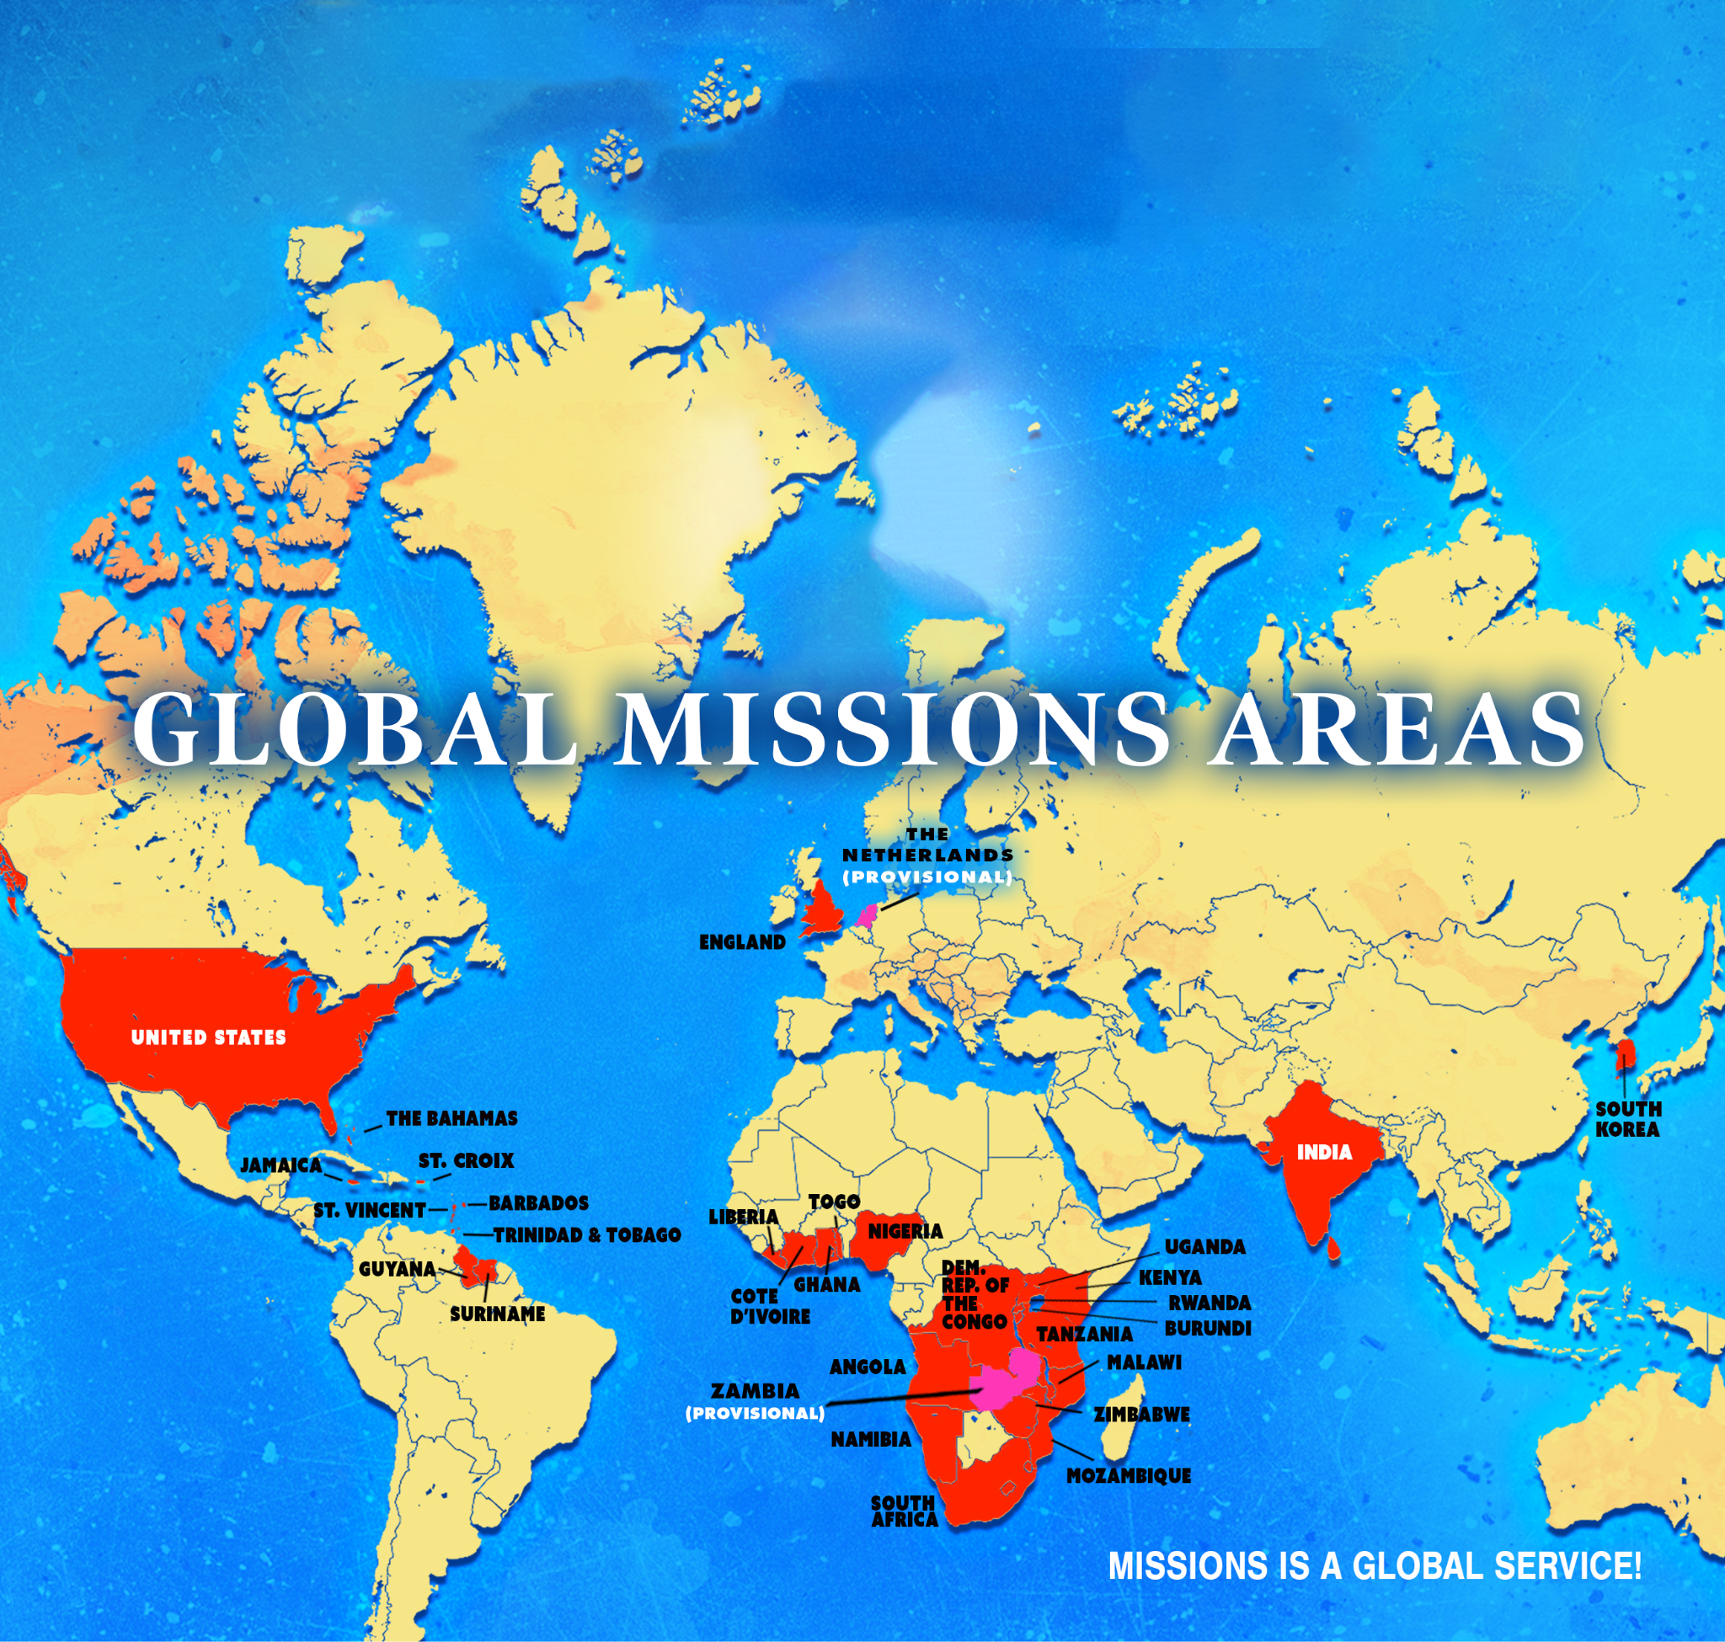

MISSIONS’ OFFERING APPEAL

MISSIONS' OFFERING APPEAL: GO, GIVE, & GROW in the Missions Work of God!
Zion, God is calling us to rise with purpose and power. The world is hurting, and the Church must respond. This is our moment to GO, GIVE, and GROW in the global work of the Kingdom.
GO — because the Gospel sends us.
We go to uplift communities, strengthen churches, and stand with believers across the world who need hope, justice, and encouragement.
GIVE — because mission requires sacrifice.
Your giving builds schools, supports pastors, feeds families, empowers youth, and sustains ministries from Africa to the Caribbean, from America to Europe & Asia.
GROW — because mission expands the Church.
When we engage in global mission, we grow in faith, compassion, and spiritual maturity. Missions strengthens Zion and enlarges our witness.
Zion, let us answer God's call with courage and commitment.
Let us GO where God sends, GIVE what God provides, and GROW into the Church God is shaping us to be.
Together, we will impact nations, transform communities, and advance the Kingdom of God.
GO, GIVE, & GROW — in the Missions Work of God!
With heartfelt gratitude, Executive Director for Global Missions - D. B. Cannon International President of Women's Home & Overseas Missionary Society - Sandra Crowder

NOTE:
Please mail all donations to:
The Department of Global Missions P.O. Box 26770 Charlotte, NC 28269 *Remember to add your Episcopal Area and Conference in the memo for
proper credit!
GLOBAL MISSIONS SUNDAY 2026


Theme: Zion Methodism: A Church on the GO, A Church willing to GIVE, A Church willing to GROW!

6 Remember this: Whoever sows sparingly will also reap sparingly, and whoever sows generously will also reap generously. 7 Each of you should give what you have decided in your heart to give, not reluctantly or under compulsion, for God loves a cheerful giver. 8 And God is able to bless you abundantly, so that in all things at all times, having all that you need, you will abound in every good work. 9 As it is written: “They have freely scattered their gifts to the poor; their righteousness endures forever.”
10 Now he who supplies seed to the sower and bread for food will also supply and increase your store of seed and will enlarge the harvest of your righteousness. 11 You will be enriched in every way so that you can be generous on every occasion, and through us your generosity will result in thanksgiving to God.
2 Corinthians 9:6-11 (NIV)

(The suggested observance for Global Missions Sunday is September 27, 2026, or any date the local church designates.)

