ORDER OF WORSHIP
Theme: Securing Zion’s Future by Sharing Our Faith Effectively through Our Time, Talents, Treasures & Thoughts!
THE ORGAN PRELUDE THE PROCESSIONAL HYMN “This is the Day!” AMEZH #42
THE CALL TO WORSHIP Worship Leader We come now to give thanks and make mention of the needs of others in our prayers. We come now to worship our God with love and faith towards the Lord Jesus and towards all of God’s creation!
THE INVOCATION Adapted from the Prayer of Saint Francis by DBC A Missionary Dear God, make us tools to be used in Your service; where there is hunger, let us share bread, where there is hurt, healing, where there is suffering, comfort, where there is disaster, assistance, where there is homelessness, shelter, and where there is sin-sickness, salvation. O Divine Master, grant that we may share our time, talents, treasures and thoughts with those in need of missions’ blessings. For it is in sharing that we are blessed, it is in serving that we are a blessing, and it is in seeking to help others that we partner with God in missions. Amen.
THE HYMN OF PRAISE “O Zion Haste, Thy Mission High Fulfilling” AMEZH #380

THE RESPONSIVE READING A Missionary Leader: Go and make disciples of every nation, baptizing in the name of the Holy Trinity (Father, Son & Holy Spirit)
People: Teach all to obey the commands of God and God will be with us! (Matthew 28:19)
Leader: God’s missional Spirit is upon all of us because we are anointed to preach the Gospel to the poor, mend broken hearts
People: Preach liberation to the oppressed and freedom to the imprisoned! (Isaiah 61:1)
Leader: Each of us should utilize our gifts and graces to serve others
People: As Faithful stewards of God’s myriad forms of grace and mercy (1 Peter 4:10)
Leader: We should take time to serve, share our talents with the world, give generously of our treasures and think about God’s mission mandate
TOGETHER: We serve, share, give and love others with a missional intensity as unto God (Colossians 3:23)

THE AFFIRMATION OF FAITH GLORIA PATRI
THE MUSIC MINISTRY
THE SCRIPTURE LESSON Philemon 1:1-7 A Missionary THE PASTORAL PRAYER/RESPONSE
THE MISSIONS APPEAL (See back of this bulletin) A Missionary THE MISSIONS’ OFFERING
THE ANNOUNCEMENTS/GREETINGS
THE PRESENTATION OF THE PREACHER/SPEAKER A Missionary THE HYMN/SONG OF PREPARATION THE MISSIONS MESSAGE
TEXT: ________________________________________
SUBJECT: _____________________________________
THE INVITATION TO CHRISTIAN DISCIPLESHIP
GOD’S TITHES AND OUR OFFERINGS/ OFFERTORY

THE RECESSIONAL

THE MISSIONARY BENEDICTION: “God be merciful unto us and bless us and cause His face to shine upon us and give us peace.” Amen. (Adapted from Psalm 67:1)

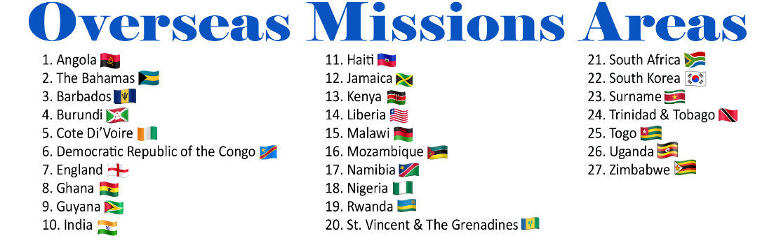

MISSIONS’ OFFERING APPEAL
Securing Our Future by Sharing Our Faith
In the light of a sharp declining of Church attendance and support, there is a heightened concern for the future of Global Missions. In spite of this bleak outlook on missions, there is hope for our future as we continue to share our faith in God. Global Missions will thrive as we continue to talk and pray about the importance and urgency of serving God through serving others! We must talk about strategies on seeking, sending, supporting and securing missionaries as we welcome, witness and win the world for Christ!
Our future is secured as we continue to share our faith through taking time to participate in missions; offering our talents and skills to enhance the productive work of missions; giving generously of our treasures to support missions’ endeavors and seriously thinking and rethinking how we do missions!
As we celebrate Global Missions Sunday 2023-2024, let us deliberately and intentionally evaluate/reevaluate our sharing by assessing/reassessing our giving of time, talents, treasures and thoughts to the mission of God! We participate in securing Global Missions as we hasten to fulfill to the highest God’s mission mandate. Let us give holistically in and of our time, talents, treasures and thoughts!
So if you do not have time to go, send off your treasures! If you have no treasures to spare, share your gifts and talents! If you think you have no time, talent nor treasure, at least think about missions by talking and praying about missions’ priority and urgency…our future depends on this!

NOTE:
  - Please mail all donations to:
  - The Department of Global Missions
  - P.O. Box 26770 Charlotte, NC 28269

GLOBAL MISSIONS SUNDAY 2023
Theme: Securing Zion’s Future By Sharing Our Faith Effectively through Our Time, Talents, Treasures & Thoughts!

“… and I pray that the sharing of your faith may become effective for the full knowledge of every good thing that is in us for the sake of Christ.”
Philemon 1:6 (ESV)

(Suggested observance for Global Missions Sunday is September 24, 2023 or any date the local church designates.)

